**Lecture 50** – How to use the course

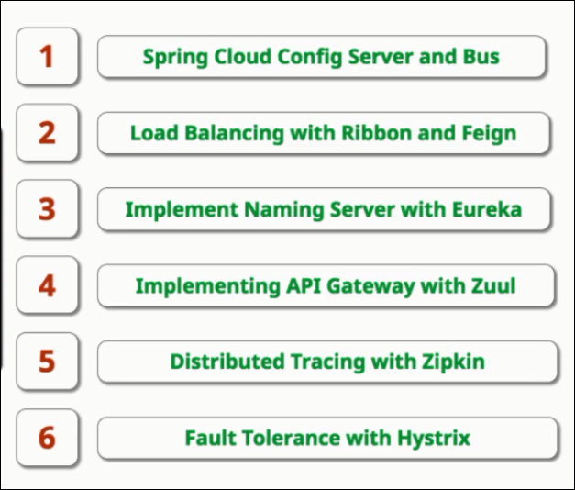

**Lecture 51** – Introduction to Micro services.

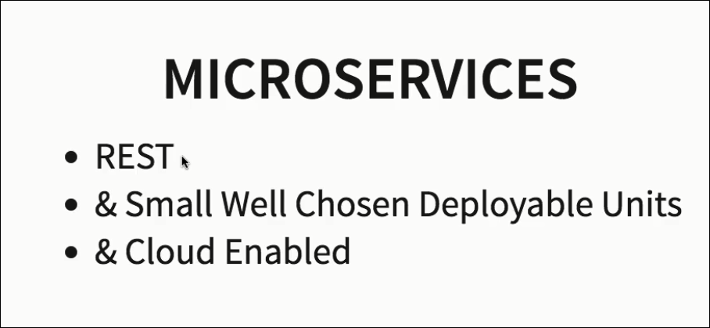

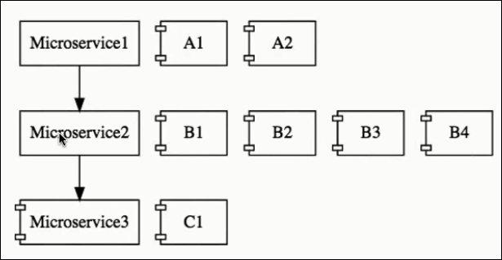

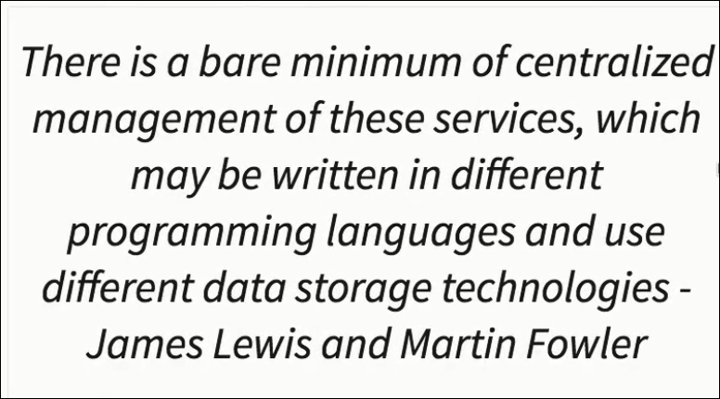

**Lecture 52: Challenges with MicroServices**

1. BOUNDED CONTEXT – How to separate boundary for each service
2. CONFIGURATION MGMT- how to keep different env & respective variables separate
3. DYNAMIC SCALING(scale up & down) – ramp up/down & load balance between available instance .
4. VISIBILITY- Debugging . If there is a but where is it , by tracing the request propagation we can know the micro service which is having issue.

Monitoring the micro services.

1. PACK OF CARDS – Critical service going down will create ripple effect & crash entire system. Thus fault tolerance is required in your micro services.

**Lecture 53: Introduction to Spring Cloud**

Ref: <https://projects.spring.io/spring-cloud/>

Spring Cloud provides tools for developers to quickly build some of the common patterns in distributed systems (e.g. configuration management, service discovery, circuit breakers, intelligent routing, micro-proxy, control bus, one-time tokens, global locks, leadership election, distributed sessions, cluster state).They will work well in any distributed environment, including the developer's own laptop, bare metal data centres, and managed platforms such as Cloud Foundry.

Its not one framework , its a conglomerate of various frameworks to provide cloude based solution.

**Spring Cloud Config Server :**Configuration of different services of the distributed system in one centralized location on Git & SpringCloud helps to expose these configs to various service centrally

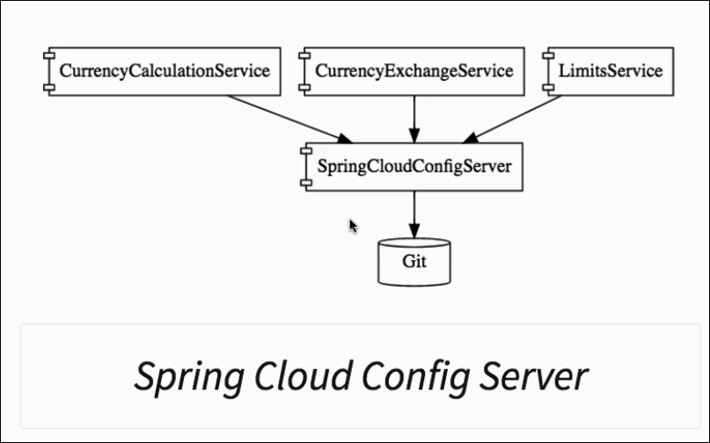

Dynamic Scaleup & down:

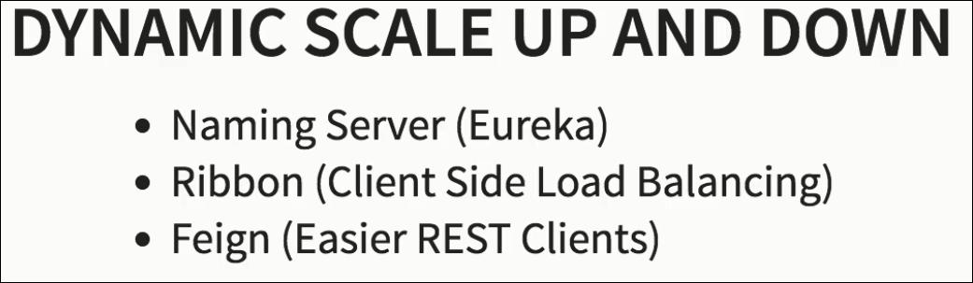

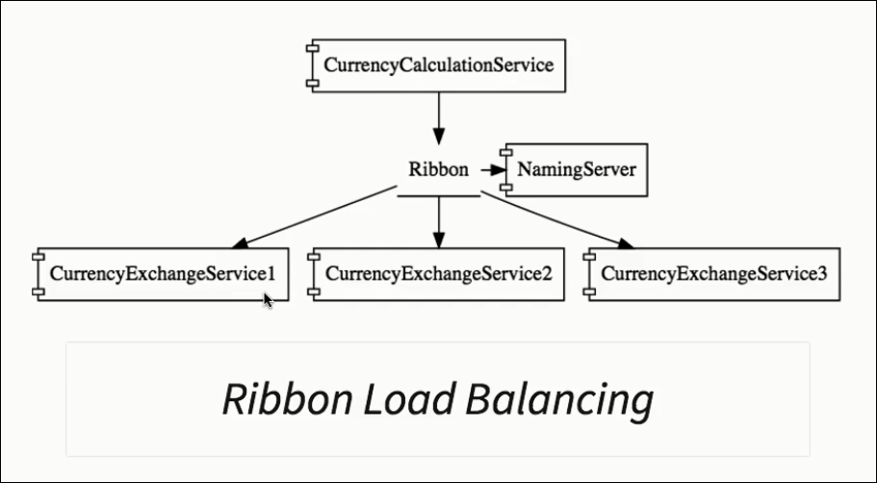

**Visibility & Monitoring: Health/logs/console**

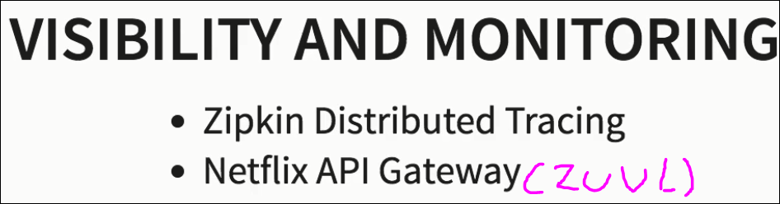

Robustness: Make system tolerate fault



**Lecture 54:** Micro services Advantages:

1. ADAPTION OF NEW TECHNOLOGY
2. DYNAMIC SCALING
3. FASTER RELEASE CYCLES

**Lecture 55:** USE A STANDARDZISED SET OF PORTS as described below:

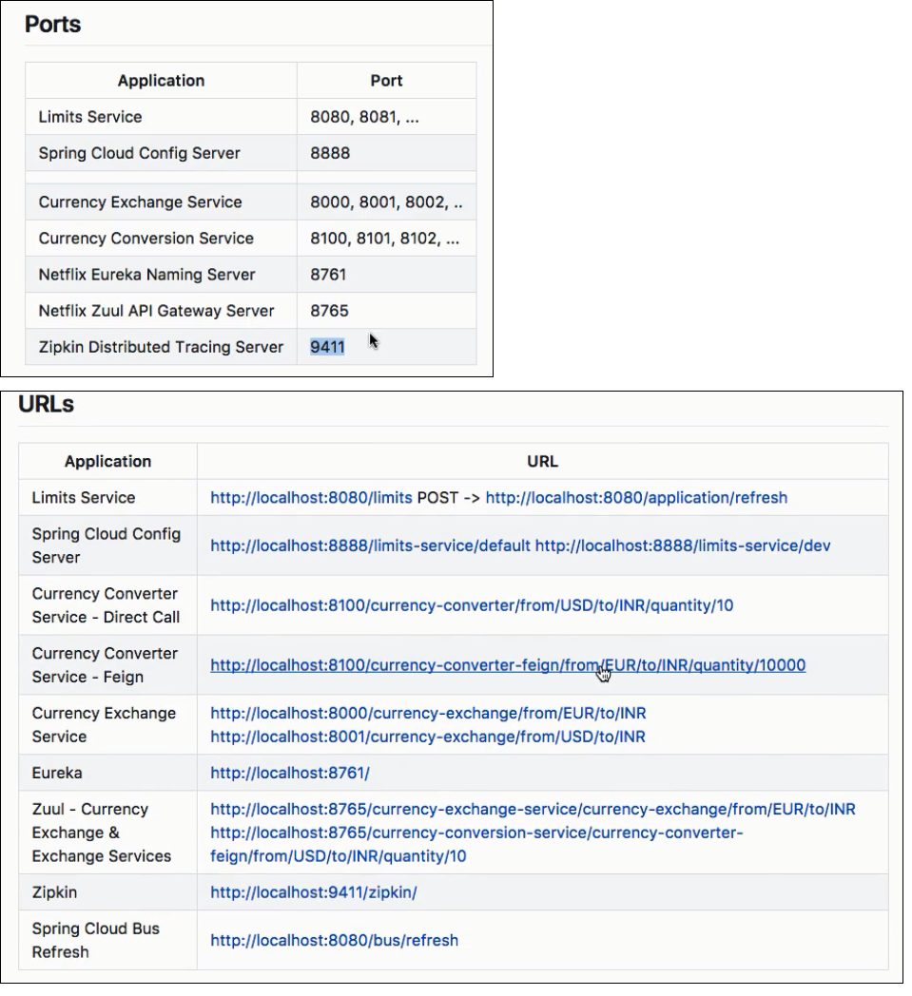

**Lecture 56,57,58,59,60: Limits Service & Spring Cloud Config Server setup**

**Action1: Create Limit Service**

**Step1:** enter the below configuration & hit **Generate Project**

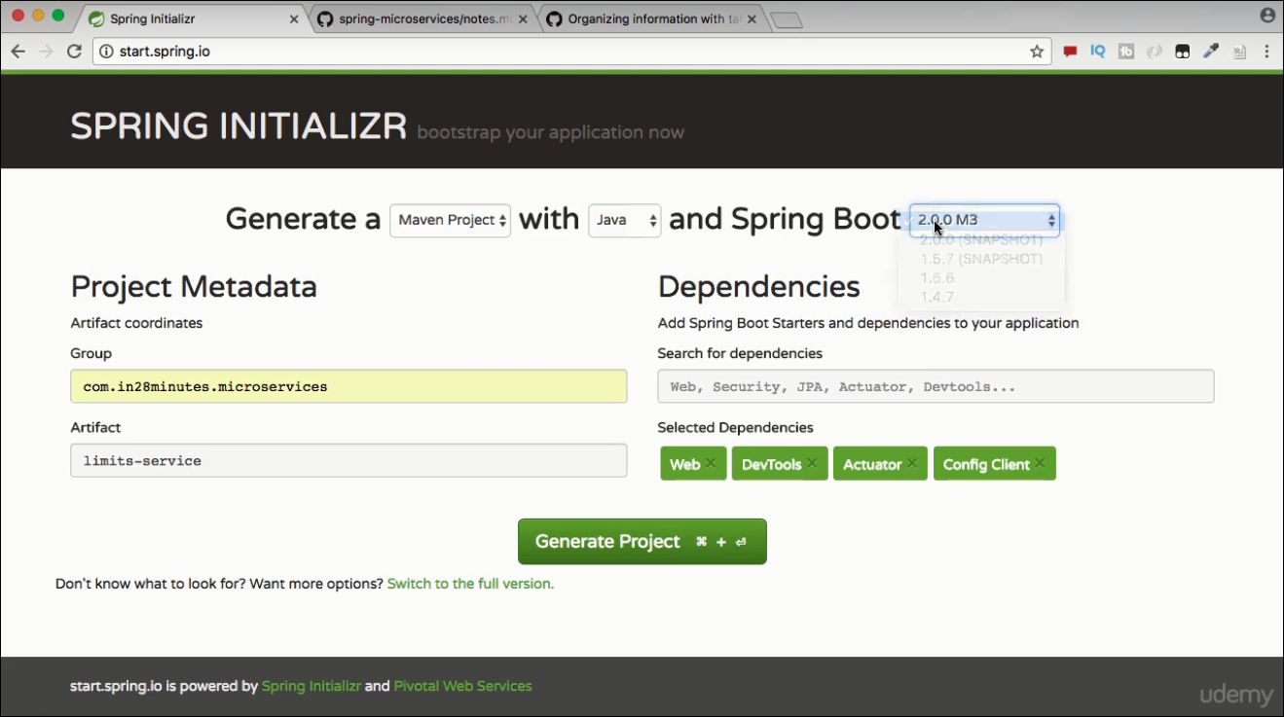

**Step2: Import that project to your workspace.**

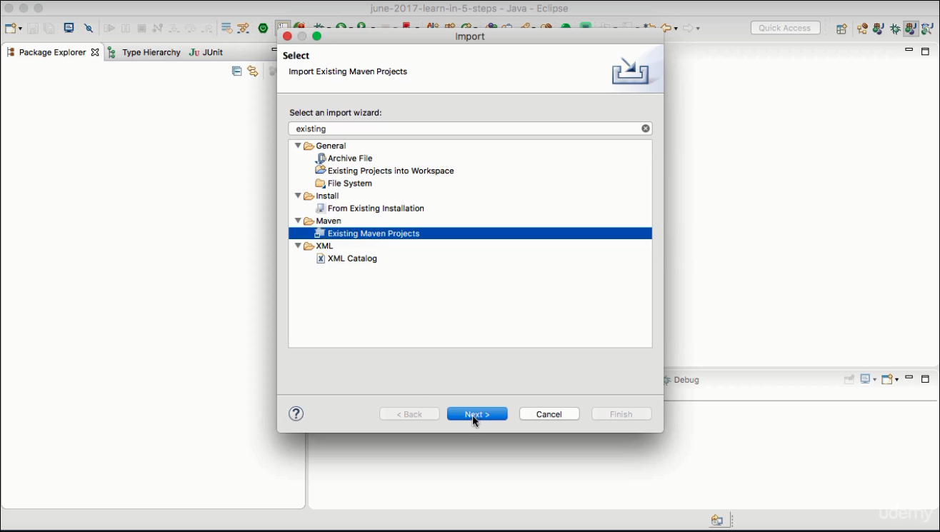

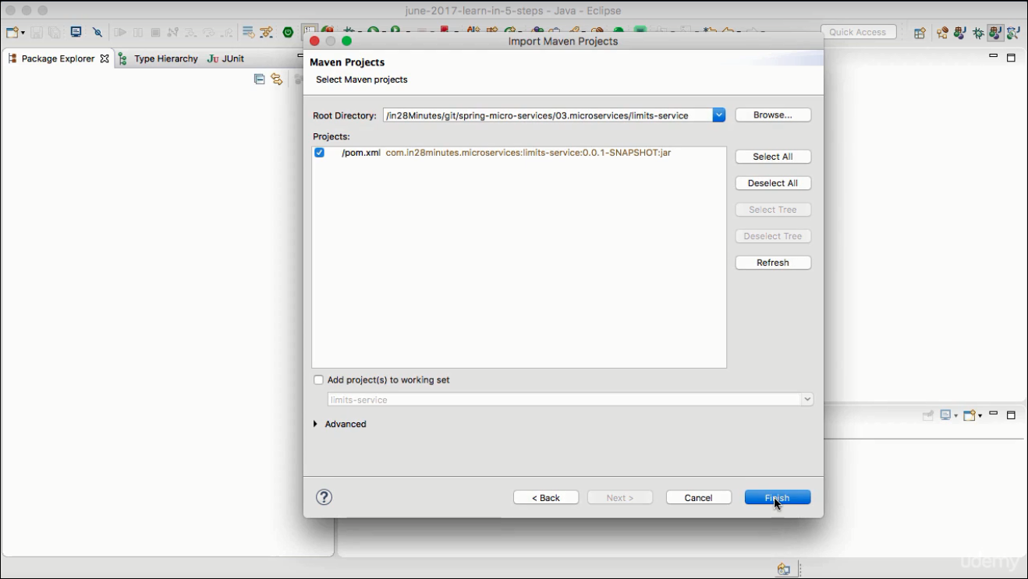

Lect

**Step3:** Start the LimitsServiceApplication.java as Java application ( it will take default port as 8080)

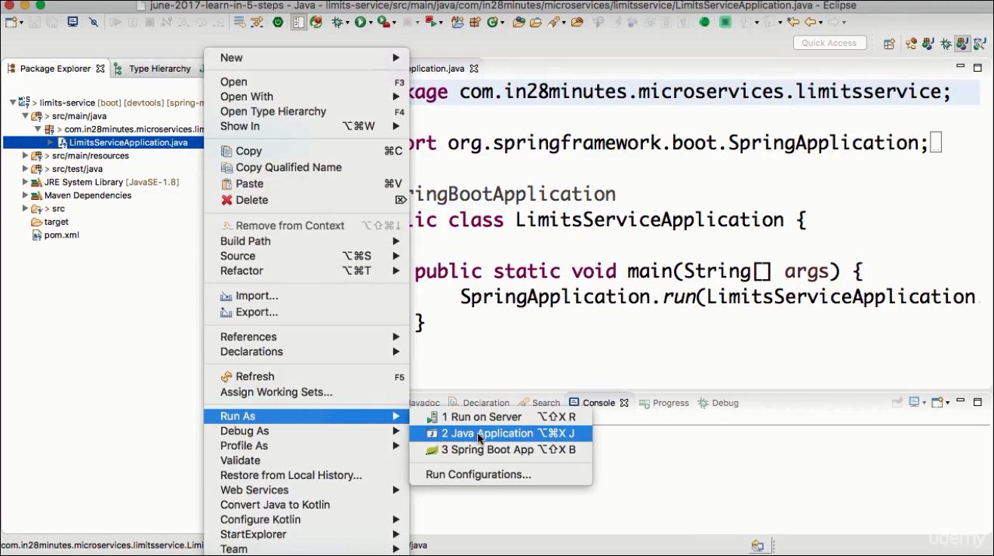

**Approach1:** get the limit service by hardcoding it

**Step1:**Now lets add application name to the **application.properties** . This will help in identifying the app.

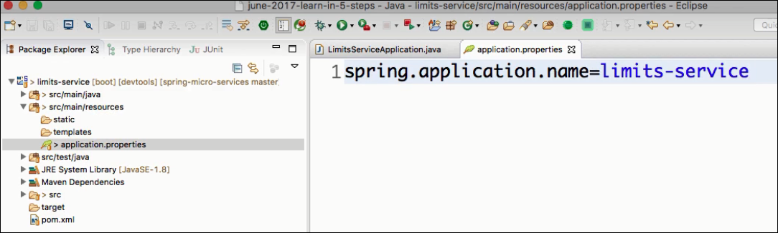

**Step2:**  Add LimitsConfiguration Controller & respective methods

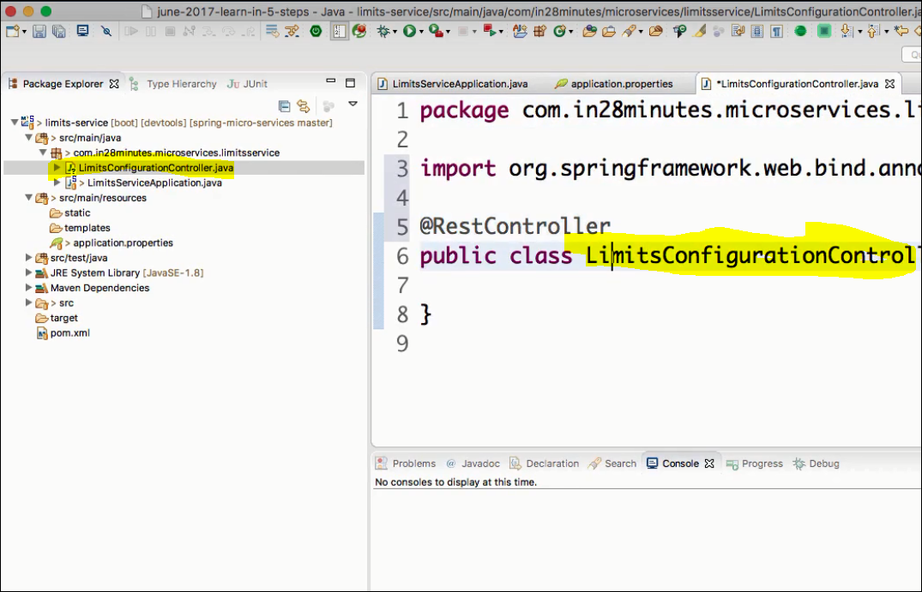

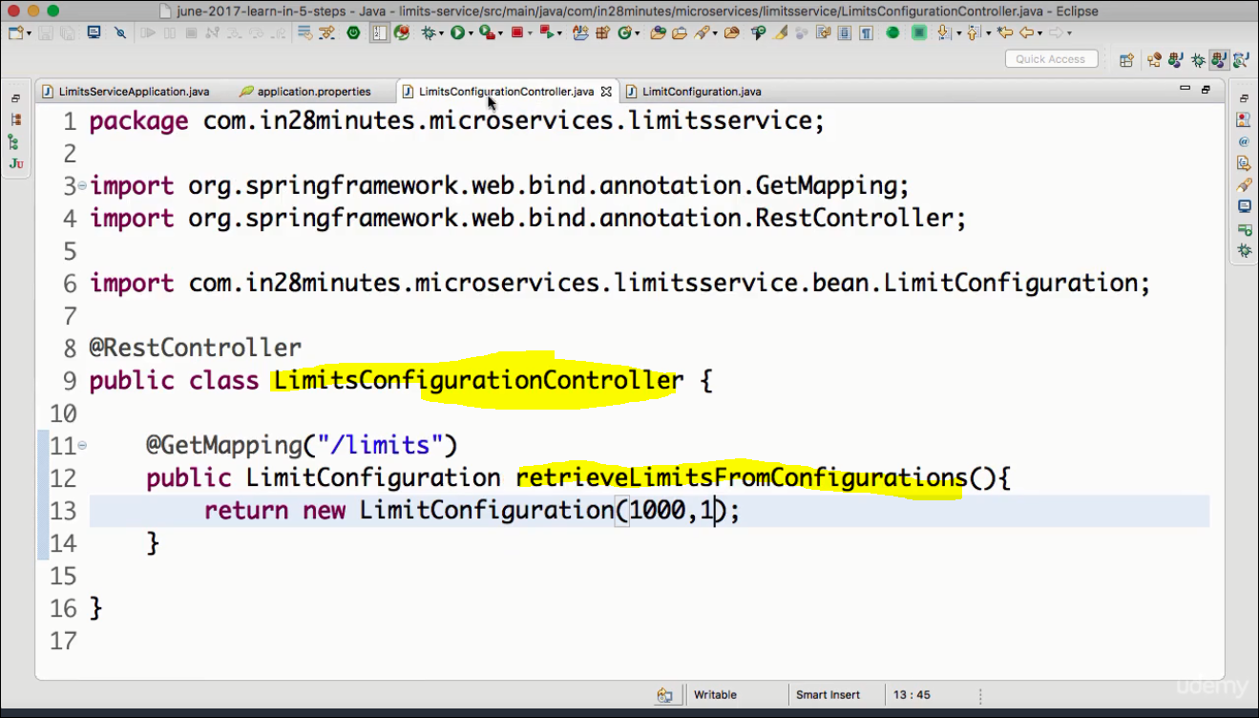

**Step3:** Add the method & Return type ( define he return type class)

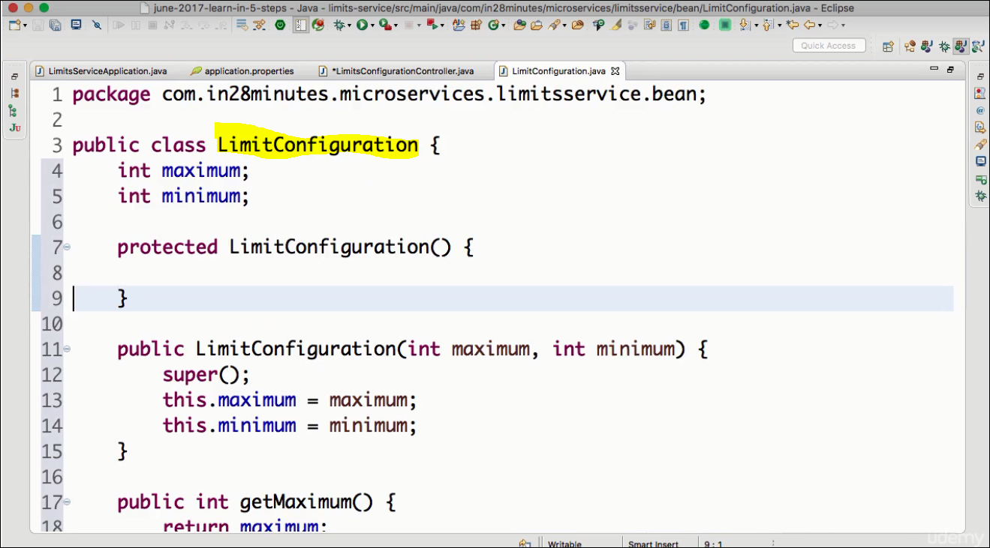**Step 4:**execute postman rest client to seethe response

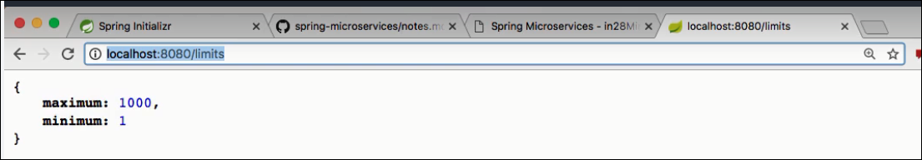

**Approach 2:** Get the value from application.properties file

**Step1:** Add the min, max limits value in application.properties file

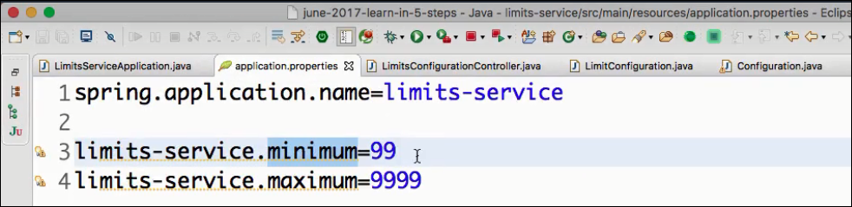

**Step2:** Add the class **Configuration** (to read the values from properties). Do generate getters/setters and default constructors.

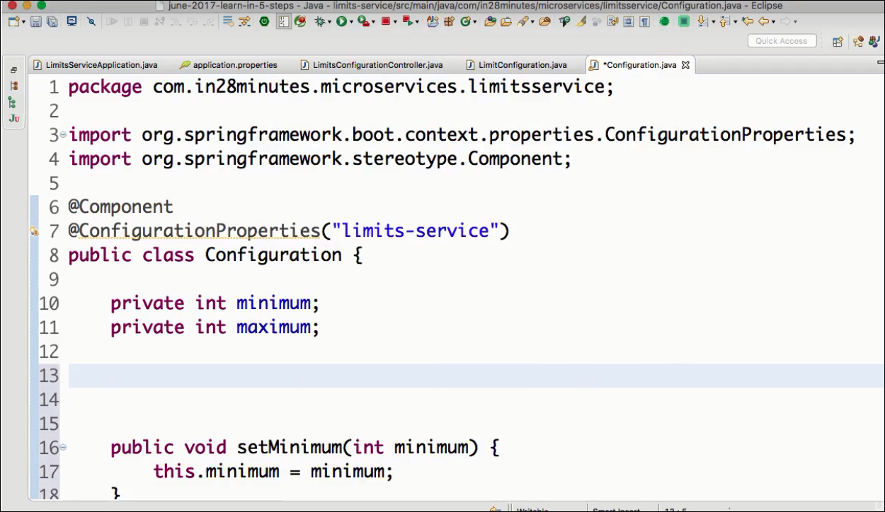

**Step3:** Autowire this class **Configuration** in **LimitServiceController**

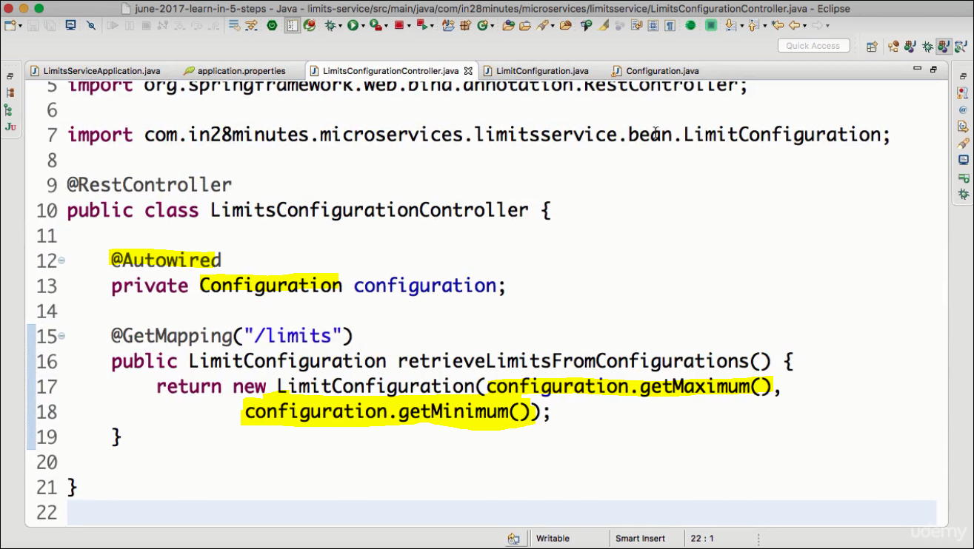

**Step4:** Test it from browser/postman.

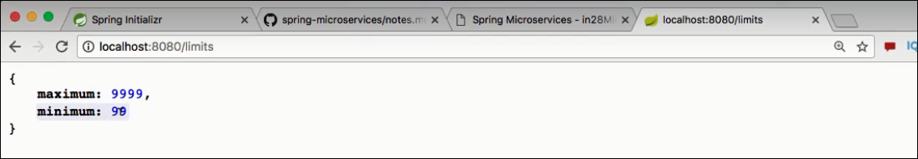

**Action2: Create The Config Server:**

**Step1:** create the project from Spring initializer

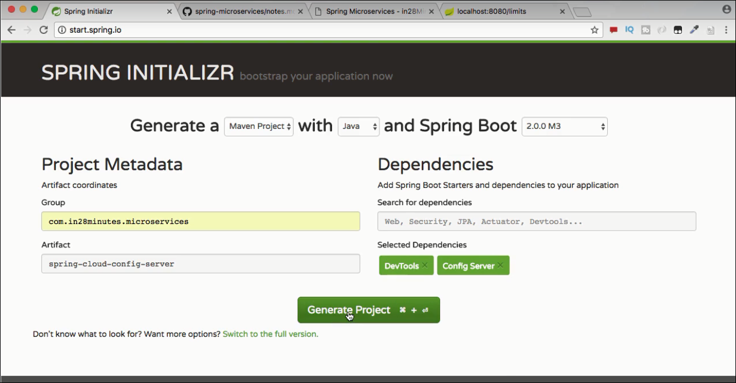

**Step2: Import it to your workspace**

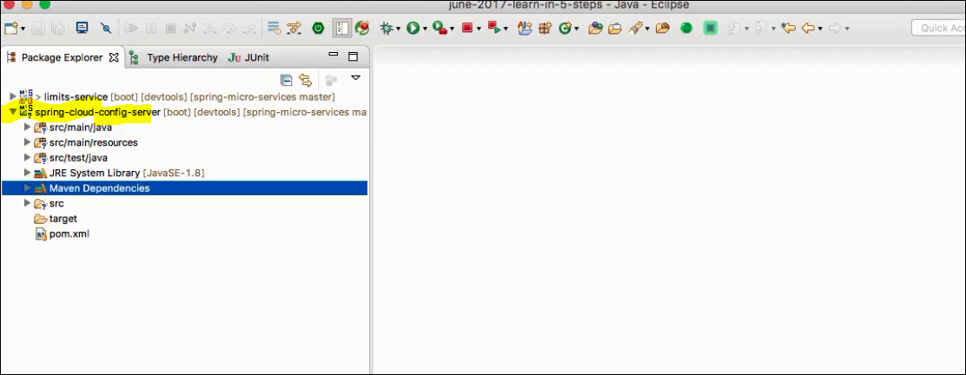

**Note : the below dependency in the pom is for config-server**

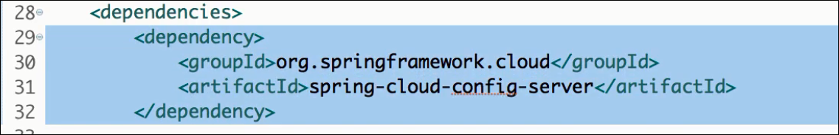

**Step3: Define the App name & port ( ref the standardized port/app name matrix chart)**

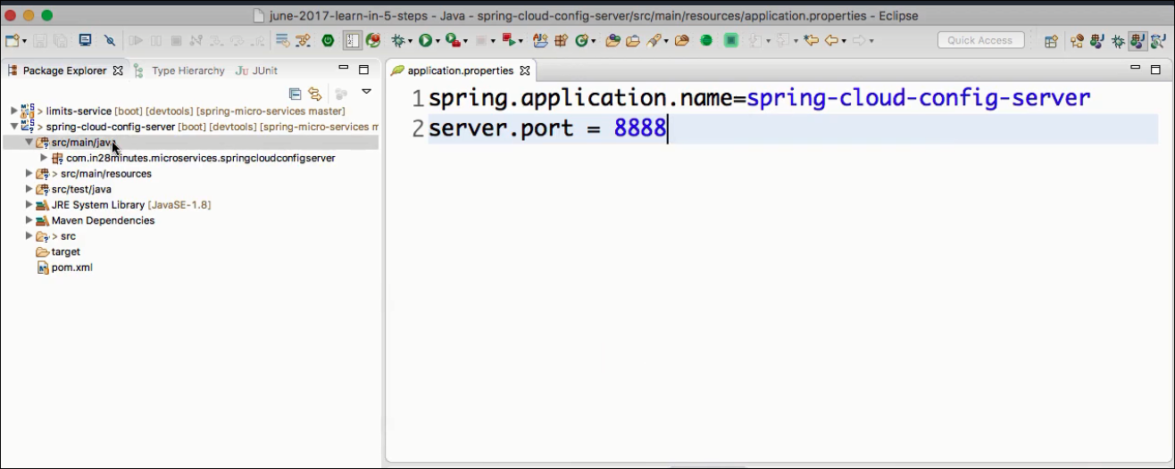

**Step 4: Install Git**

In this step , we create a local Git repository , add files to it & Commit.

cmdline$> cd *in28Minutes*git/spring-micro-services/03.microservices

cmdline$> mkdir git-localconfig-repo

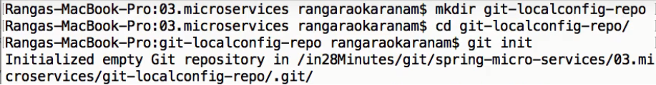

**Step5 : Link the Git Source to spring-cloud-config-server project to be used as a src**

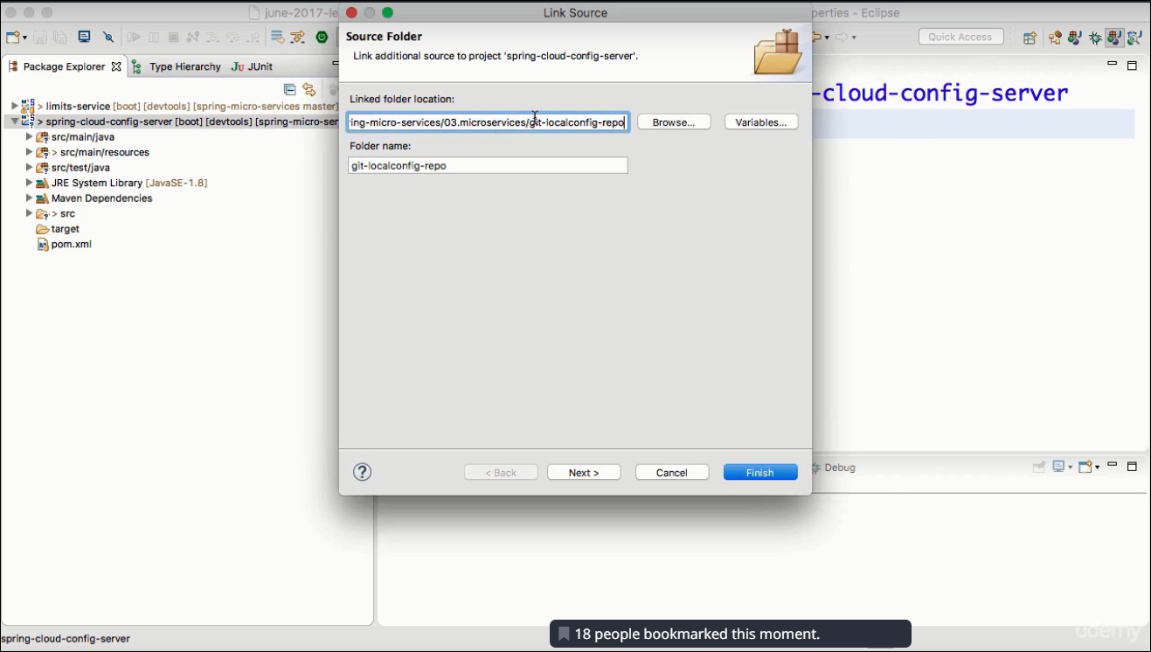

**Step 6:Add the following files to the folder git-localconfig-repo using eclipse editor:**

**limit-service.properties**

**Commit the files in the Git repo:**

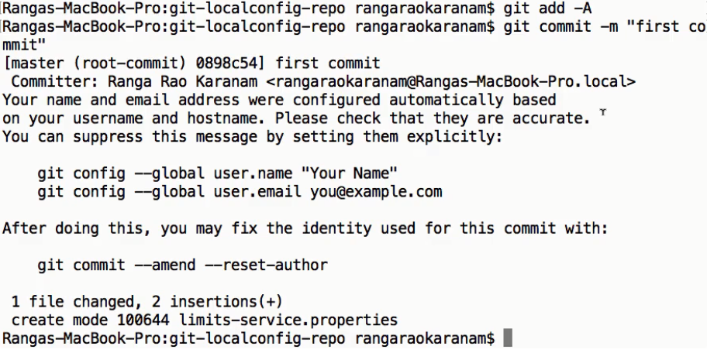

**Step 7: Point the spring-cloud-config-server to read from the Git URL:**

**spring.cloud.server.git.uri=**[**file://**](../../../../)**<path to the git-localconfig-repo>**

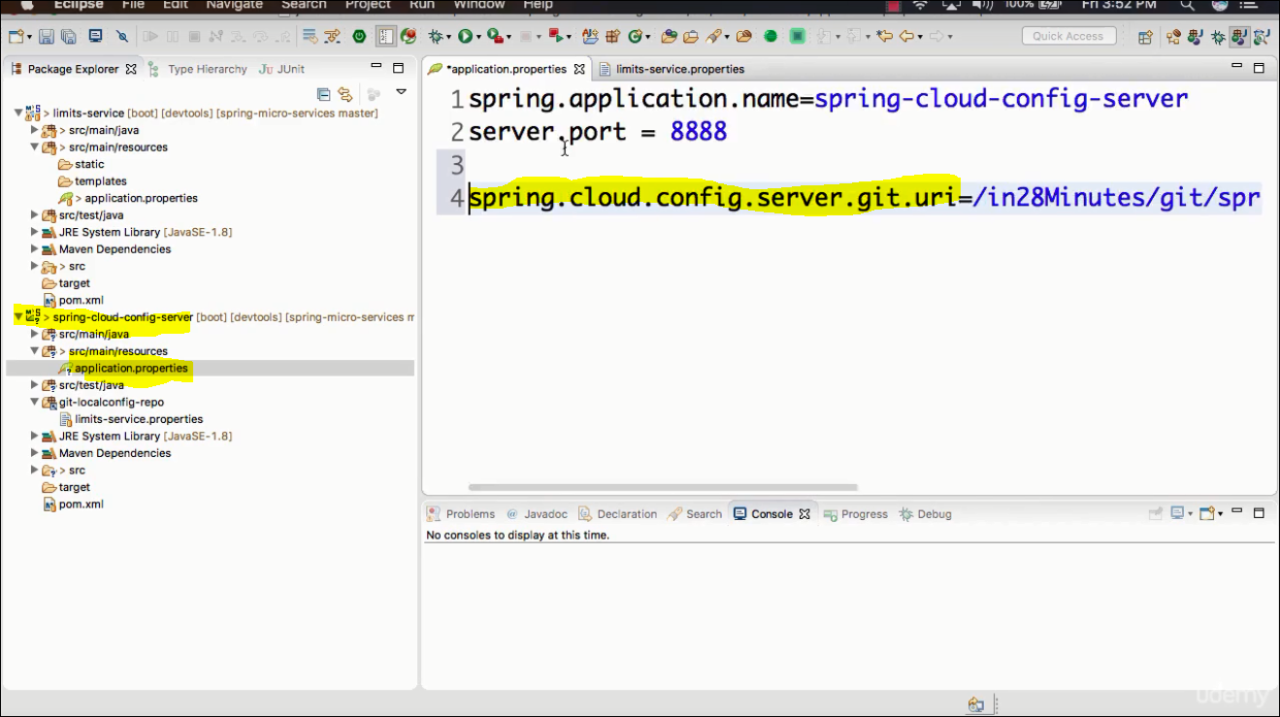

**Step 8: Enable Spring-cloud-config-server-** Add the @EnableConfigServer annotation to the SpringCloudConfigServerApplication & Restart the application.

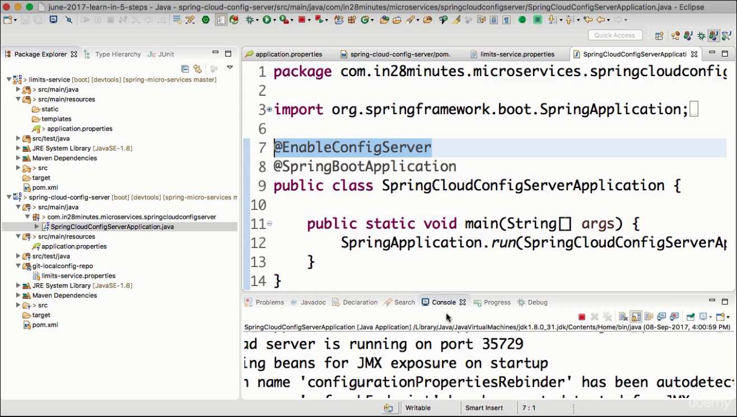

**Check if the limit-service is working fine:**

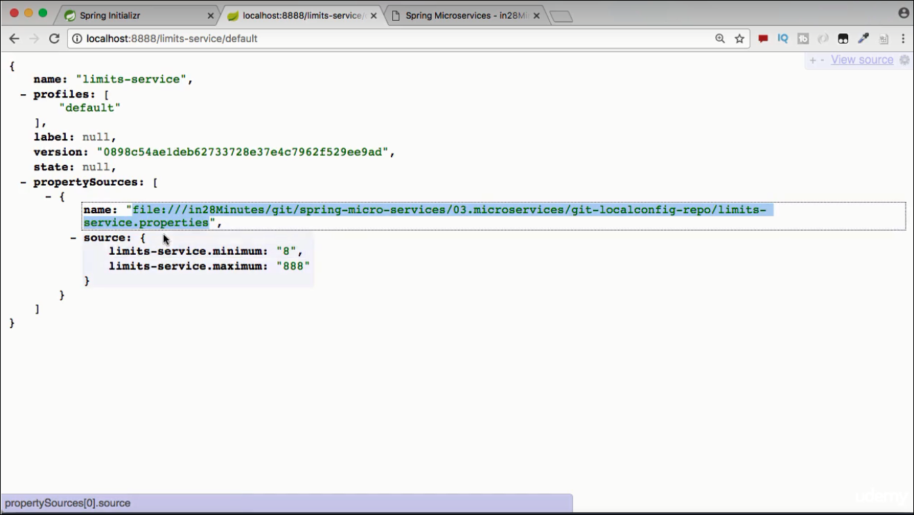

**Action3: Make it usable by multiple environment**

**Step1:** Add multiple env specific files in the git-localconfig-repo , update configuration content in these files

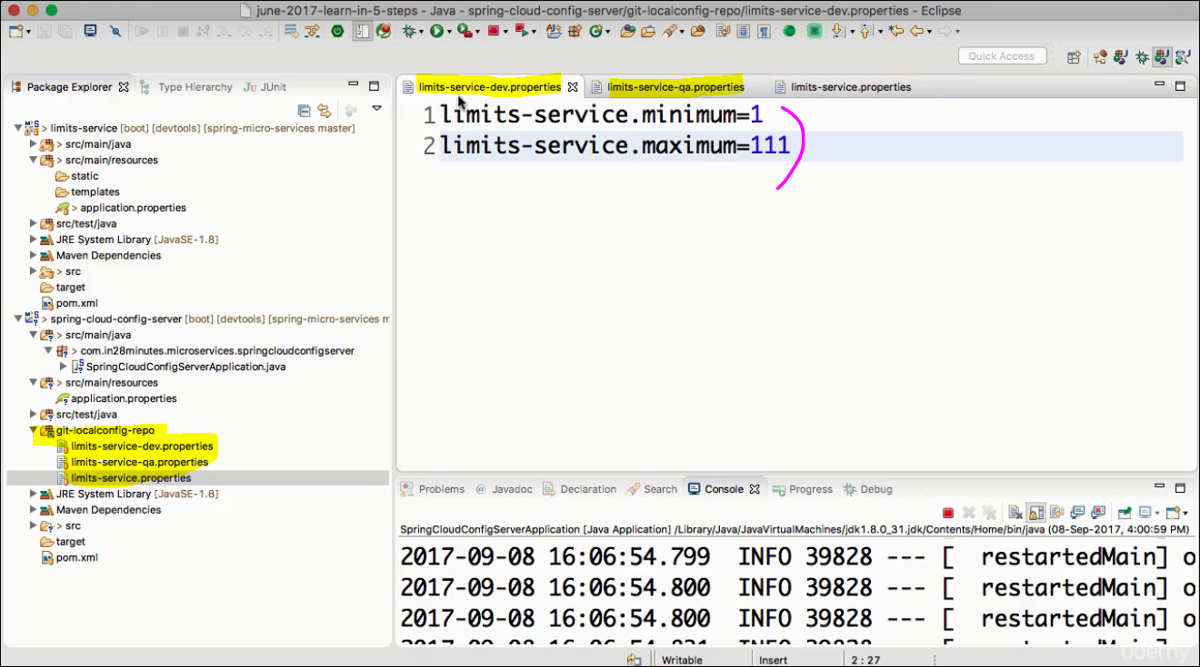

**Step2: Commit in Git**

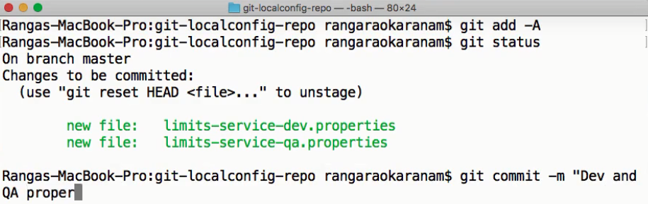

**Step3: Check the env specific response from limit-service:**

**URL:** [**http://localhost:8888/limit-service/dev**](http://localhost:8888/limit-service/dev)

**URL:** [**http://localhost:8888/limit-service/qa**](http://localhost:8888/limit-service/qa)

**Look at the properties sources priorities:**

env specific properties will be taken first , if they are not found in a specific env , then default properties value will be taken.

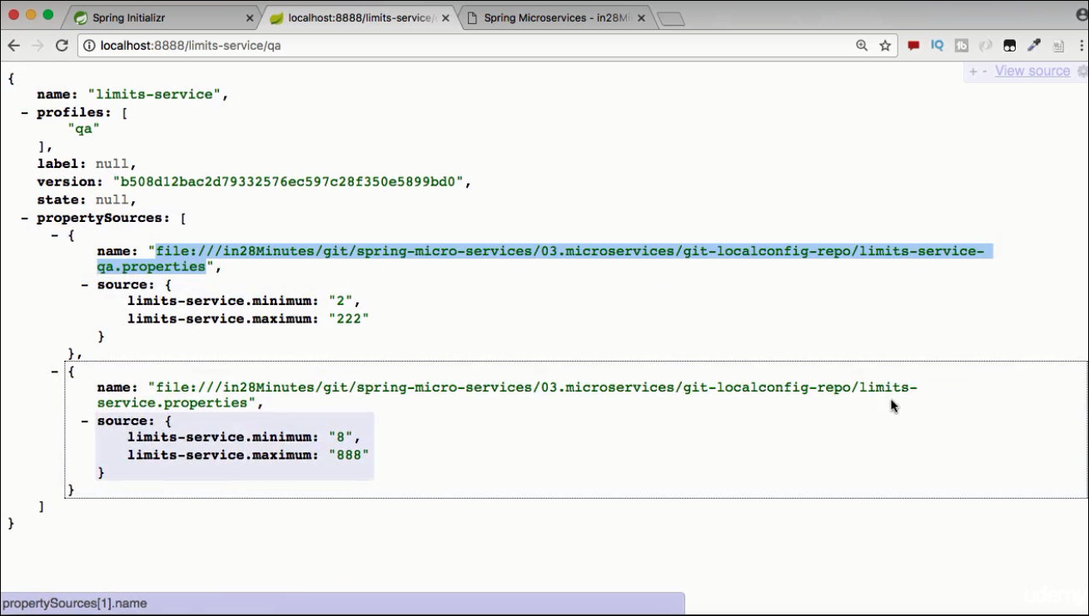

**Action4 : Link limit-service to point to spring-cloud-config-server**

**Step1:** In **limit-service** rename **application.properties** → **bootstrap.properties** & remove all other highlited configs

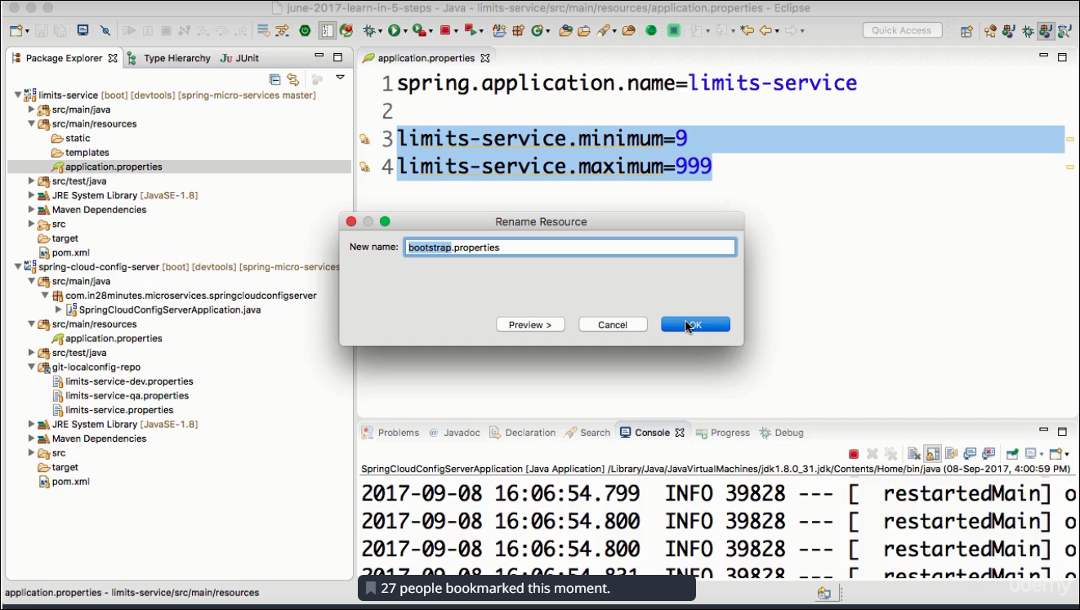

**Step2: Provide the URL for spring-cloud-config-server .Save. Restart LimitServiceApplication.**

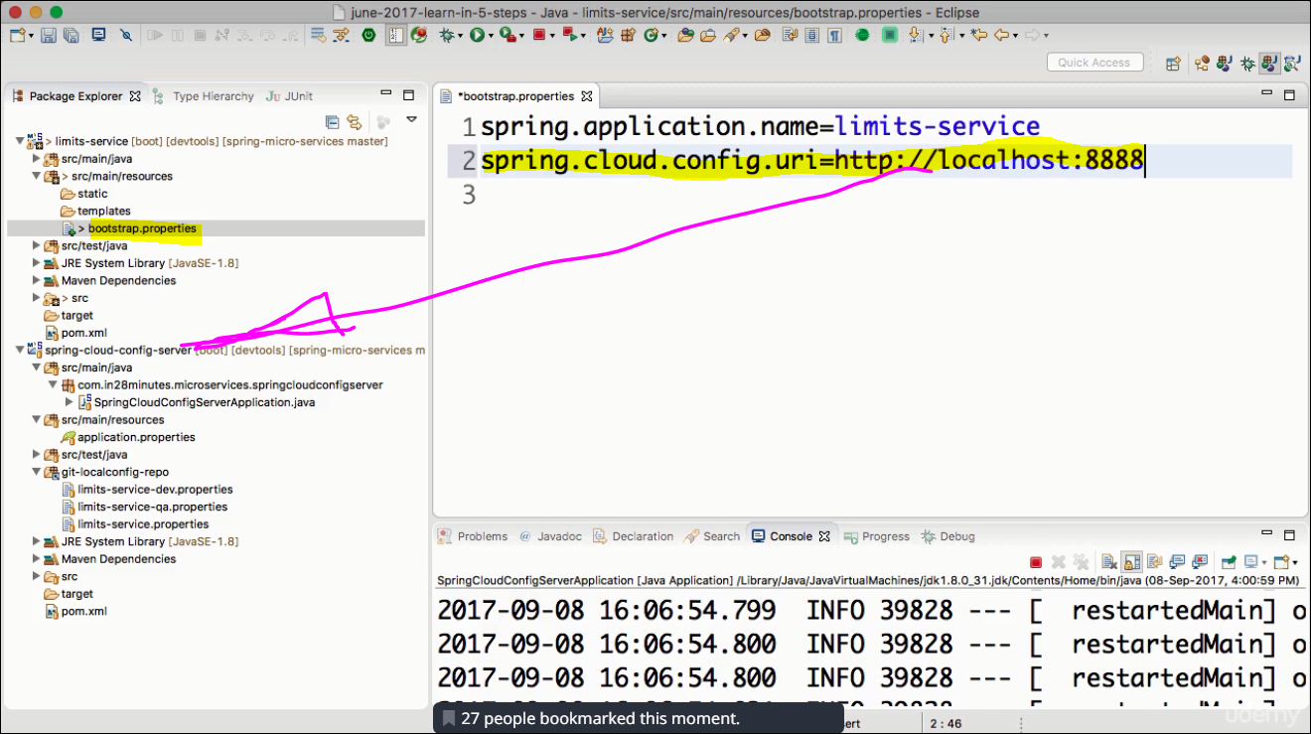

Now if u provide the url: <http://localhost:8080/limits>

this will read the default values because profiling is not activated.

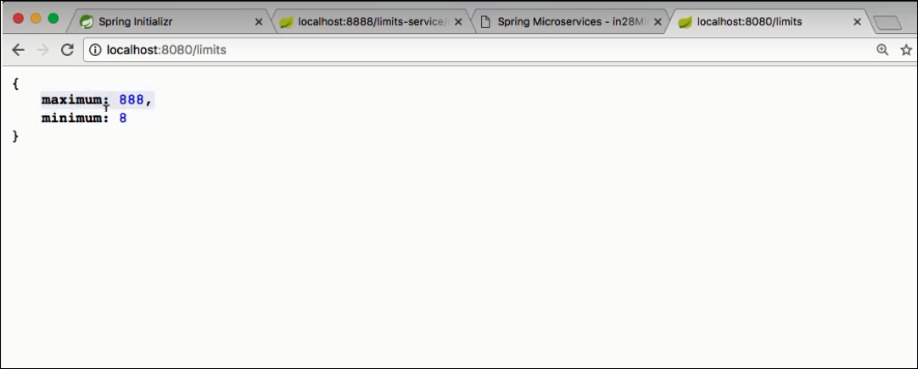

**Step3 : Configure profiling ( in Limit-service)**

Add the below properties to point point which is the active profile. In actual deployment the value to “spring.profiles.active” can be passed either from JAVA_OPTIONS (or VM_OPTIONS in PCF)

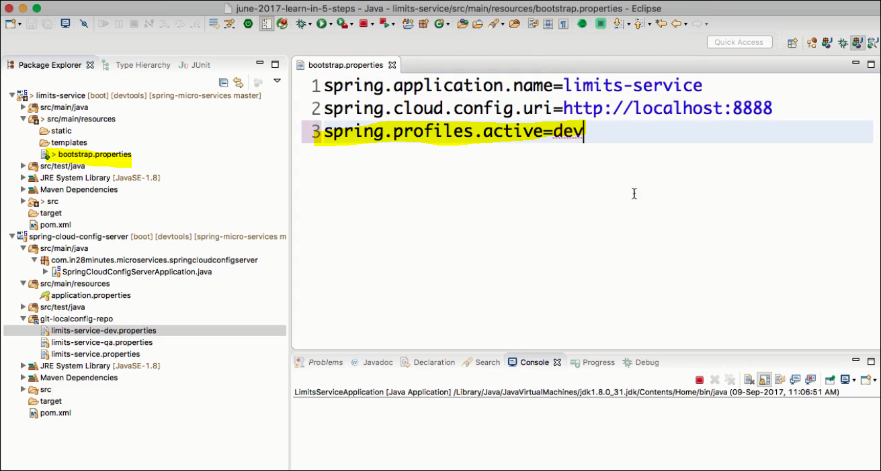

**Step 5 :** Restart Limit-service and test

